**Project Development –Delivery plan sprint-3**

IoT Based Safety Gadget for Child Safety Monitoring & Notification

**TEAM ID:PNT2022TMID02457**

# Creating Cloudant DB and integrating Node-Red with the Web UI

**Create Cloudant DB:**

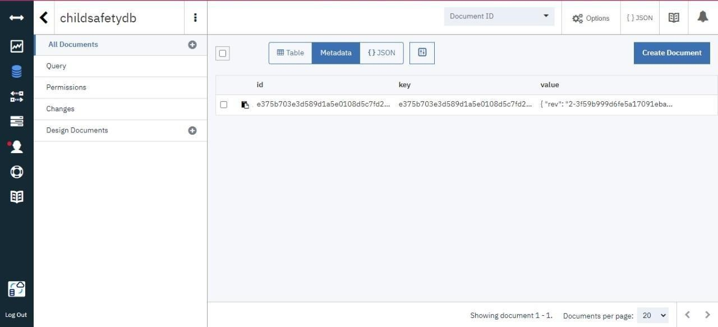

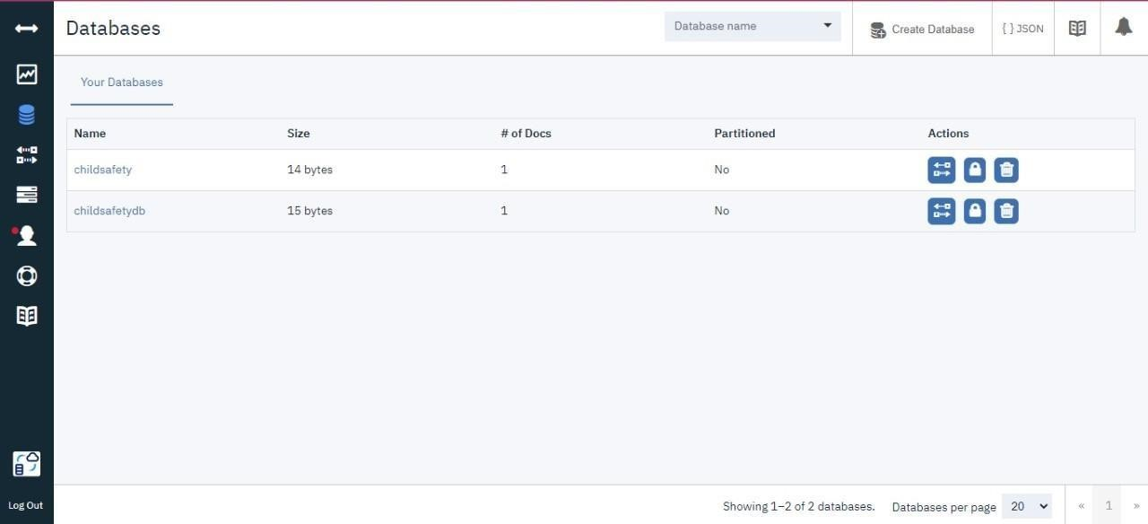

**Node-Red Service with Cloudant Database:**

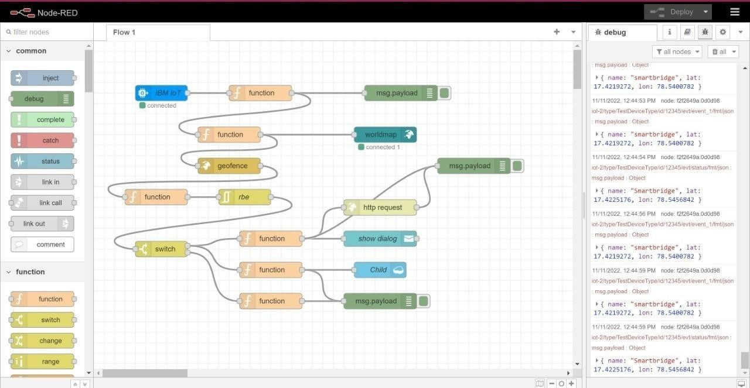

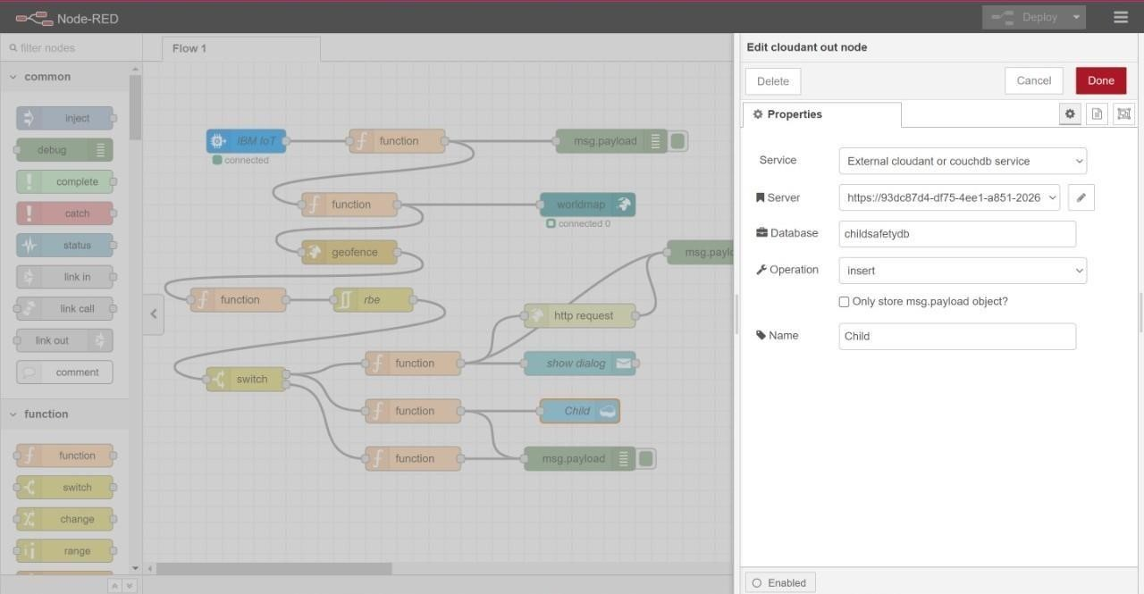

**Node-Red Dashboard(Web ui):**

